Brief
The Alternating Pressure Mattress consists of two parts: the mattress and the pump. The pump utilizes a small compressor to remain quiet and energy efficient. The control panel is simple and very user friendly.It is widely recognized that constant pressure
to a bony prominence is the leading cause of skin breakdown.The continuous movement supplied by the unit lessens the areas of constant pressure and enhances circulation.
Operation
1. Place the mattress on the bed frame with the hose end at the foot section of the bed frame.
2. Using the integrated hooks, securely hang the pump on the bedend at the foot end or place on a smooth flat surface.
3. Connect the air hoses from the mattress to the pump.
4. Plug the pump into a wall outlet. Be sure the power cord is safely away from possible hazards.
5. Turn on the power switch on the control panel of the pump. The pump will begin to inflate the mattress.
6. After inflation, adjust the mattress using the dial on the pump.


Caution
1. Do not smoke on or near the pump.
2. Keep the pump away from heated surfaces.
3. Explosion risk if used in the presence of flammable anesthetics.
4. Replace fuse as marked: T1A 250V.
Power Input:AC 220V 50Hz; 0.1A
Product Specifications

DIMENSIONS  MATTRESS (Length x Width x Height):  PUMP (Length x Width x Height): | 72″×35″×3″  (183cm×89cm×7.5cm)  10″×5″×4″  (26cm×13cm×10cm)
WEIGHT OF PRODUCT  MATTRESS WEIGHT:  PUMP WEIGHT: | 10 lbs (4.5kg)  3 lbs (1.4 kg)
WEIGHT CAPACITY  MAXIMUM PATIENT WEIGHT: | 220 lbs (100 kg)
ELECTRICAL  OPERATING POWER:  FUSES: | AC 220V 50Hz,0.1A MAX  T1A 250V
ENVIRONMENTAL CONDITIONS  OPERATING CONDITIONS  Ambient Temperature:  Relative Humidity:  STORAGE AND SHIPPING CONDITIONS  Ambient Temperature:  Relative Humidity: | 18°C to 34°C  (65°F to 94°F)  10% to 95%  -18°C to +43°C  (0°F to 110°F)  10% to 95%

Features
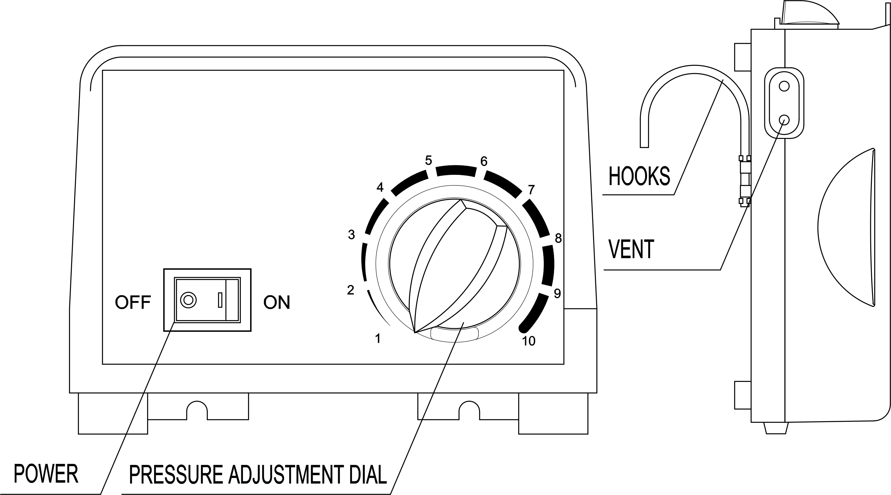

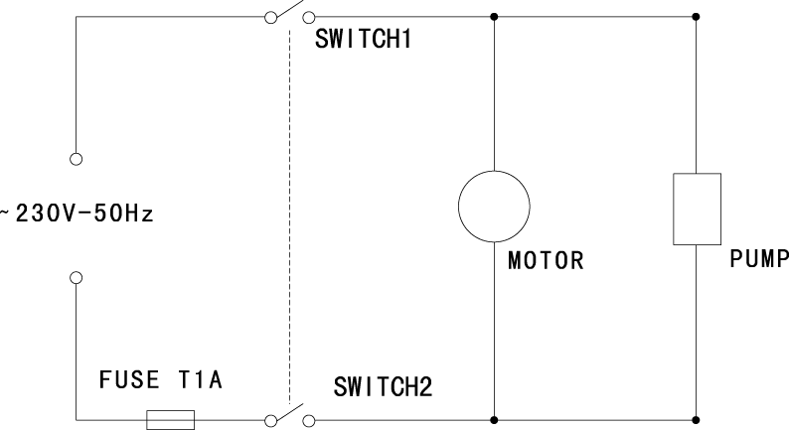
Circuit diagram

Alternating Pressure Mattress

USER MANUAL

